Practical – 2

Practical Title: Semantic HTML5 Pages with Accessibility-Ready Structure

Problem Definition: Develop static HTML5 skeletons for at least 10 Student Hub pages such as Home, About, Register, Login, Dashboard, Events, Profile, Contact, Admin, FAQ, and Feedback. Use semantic tags and accessibility-friendly structure.

Theory

Are semantic tags such as header, nav, main, section, article, aside, and footer used properly?
Answer: Yes, semantic tags like header, nav, main, section and footer are used to arrange the page properly.

References:
https://developer.mozilla.org/en- US/docs/Web/HTML/Reference/Elements?

- Are form labels, headings, image alt text, and navigation links accessible?
Answer: Yes, headings, form labels and navigation links are used properly so the pages are easy to use.
References:
https://developer.mozilla.org/

- Is the page structure consistent across all pages?
Answer: Yes, all pages have a similar structure with a header, navigation, main content and footer.
References:
https://developer.mozilla.org/

- Implementation/ Output/Result:
The Student Hub Portal was successfully implemented using HTML5 with semantic and accessibility-friendly tags. Static pages such as Home, About, Register, Login, Dashboard, Events, Profile, Contact, Admin, FAQ, and Feedback were created and tested successfully.

Evidence of Work (Screenshots)

Description: Figure 2.1 Home Page
The Home Page is created using HTML5 semantic tags with a clear structure and accessible navigation links for users.
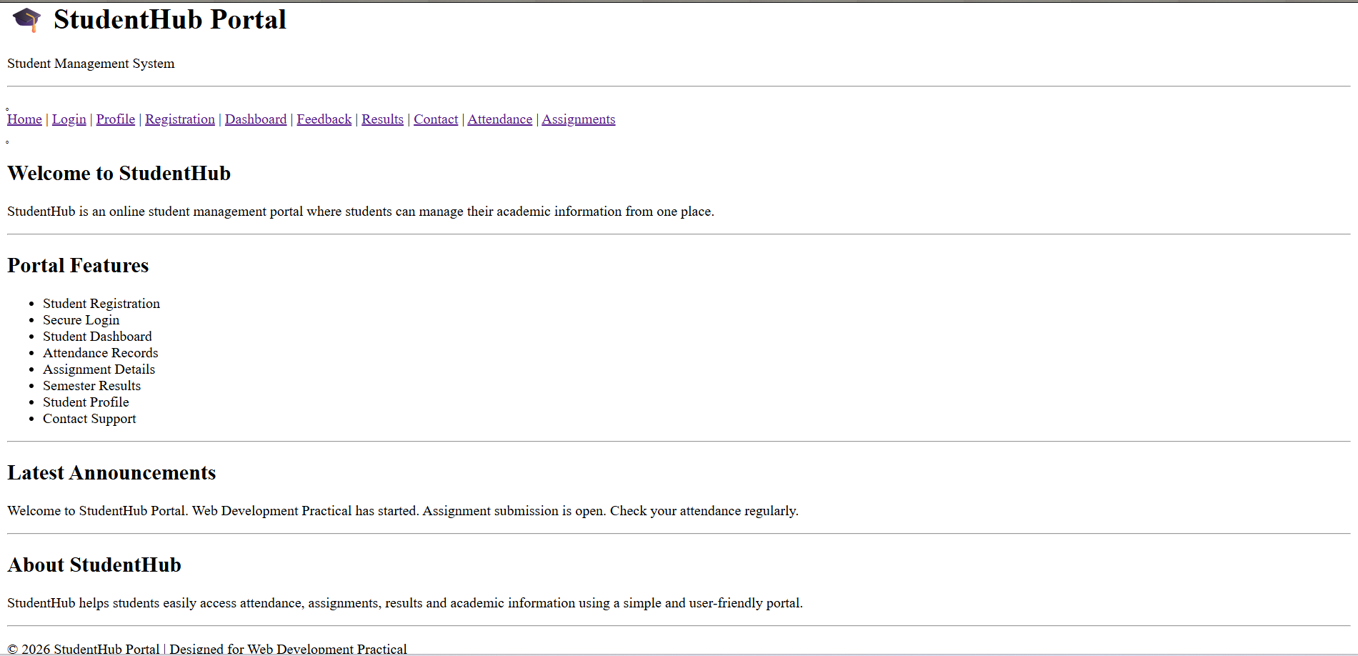

Description: Figure 2.2 shows the Login Page, created using semantic HTML5 tags with accessible form labels for email and password fields.
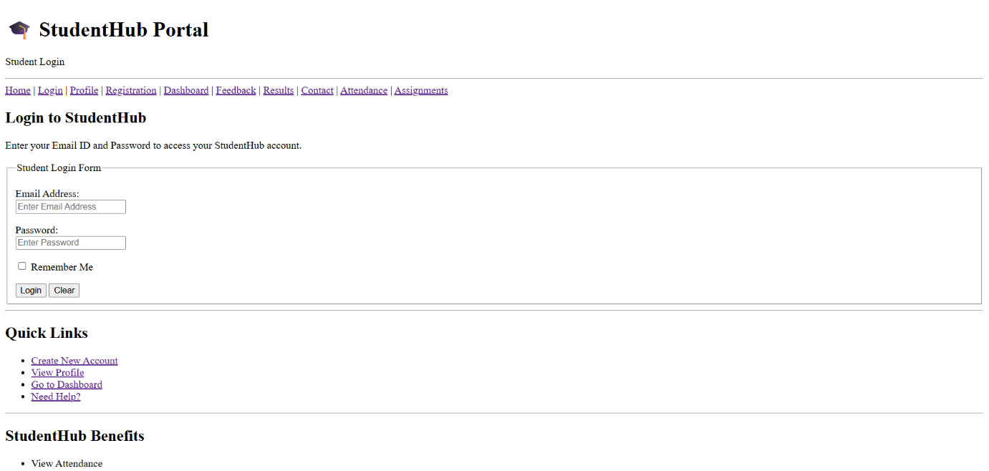

Description: Figure 2.3 shows the Profile Page, created using semantic HTML5 structure to display student information in a clear and accessible way.
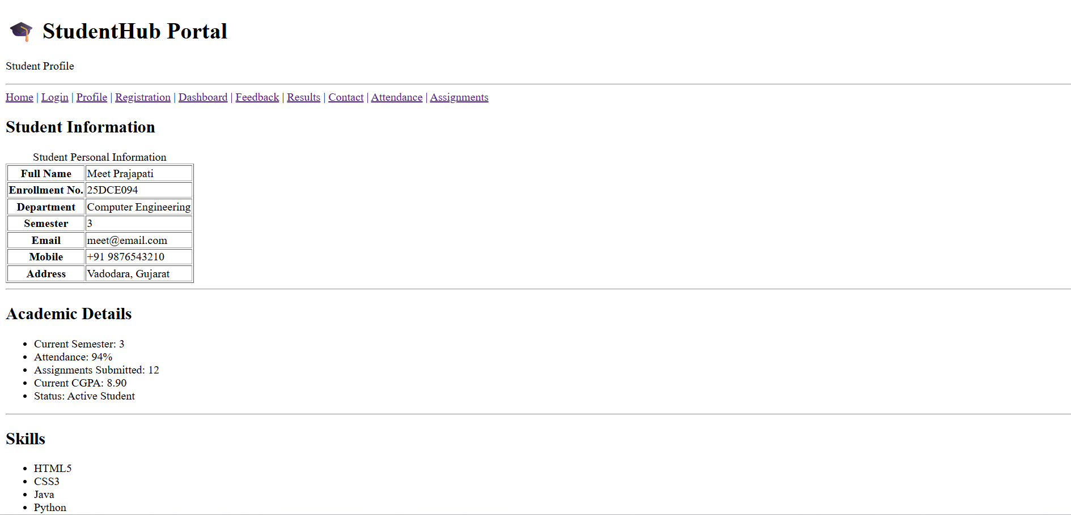

Description: Figure 2.4 shows the Registration Page, created using semantic HTML5 tags with accessible labels and input fields for student details.
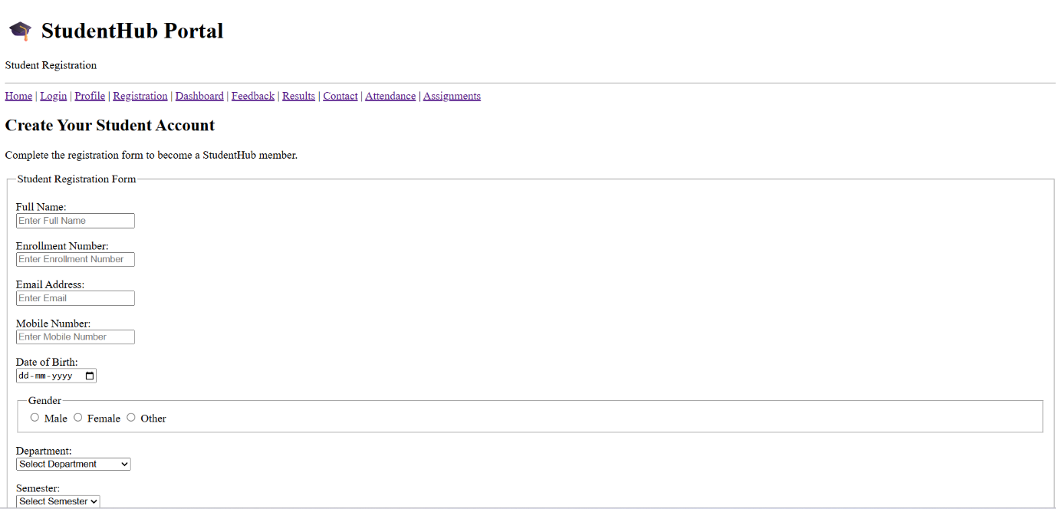

Description: Figure 2.5 shows the Dashboard Page, created using semantic HTML5 tags to organize student information and provide clear navigation to different sections.
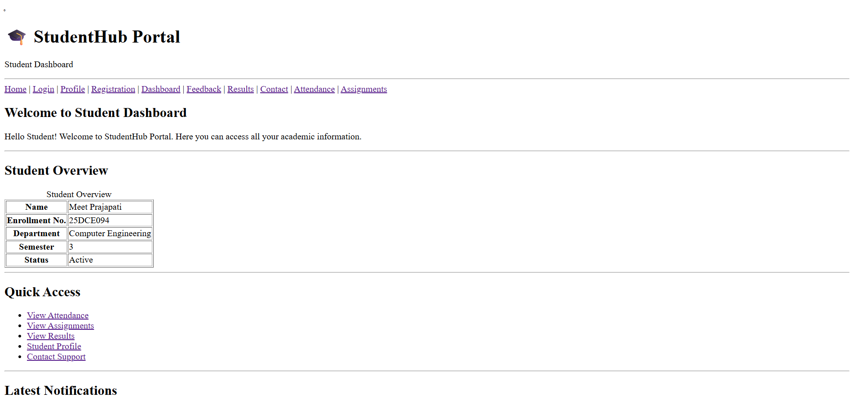

Description: Figure 2.6 shows the Feedback Page, created using semantic HTML5 tags with accessible form fields for students to submit their feedback.
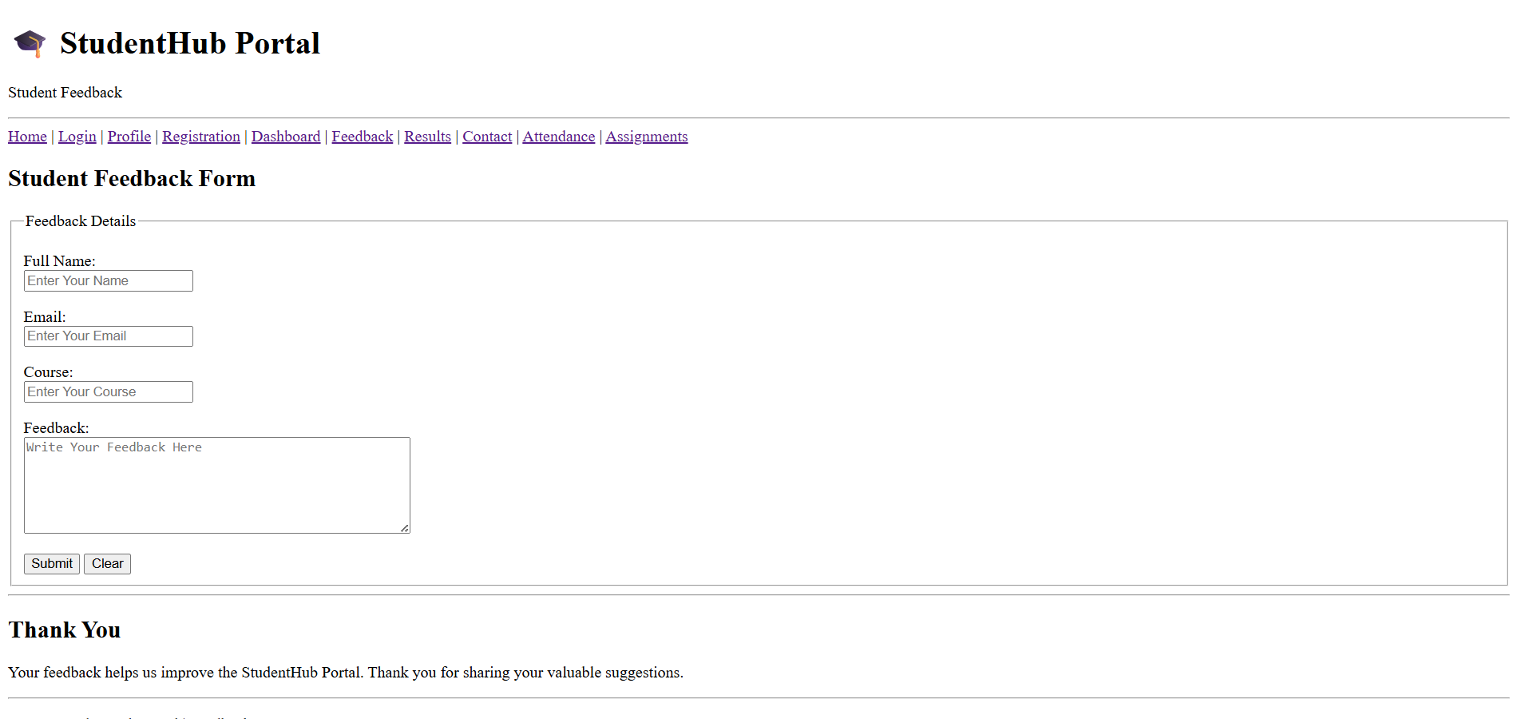

Description: Figure 2.7 shows the Results Page, created using semantic HTML5 tags to display student marks, grades, SGPA, and CGPA in a clear structure.
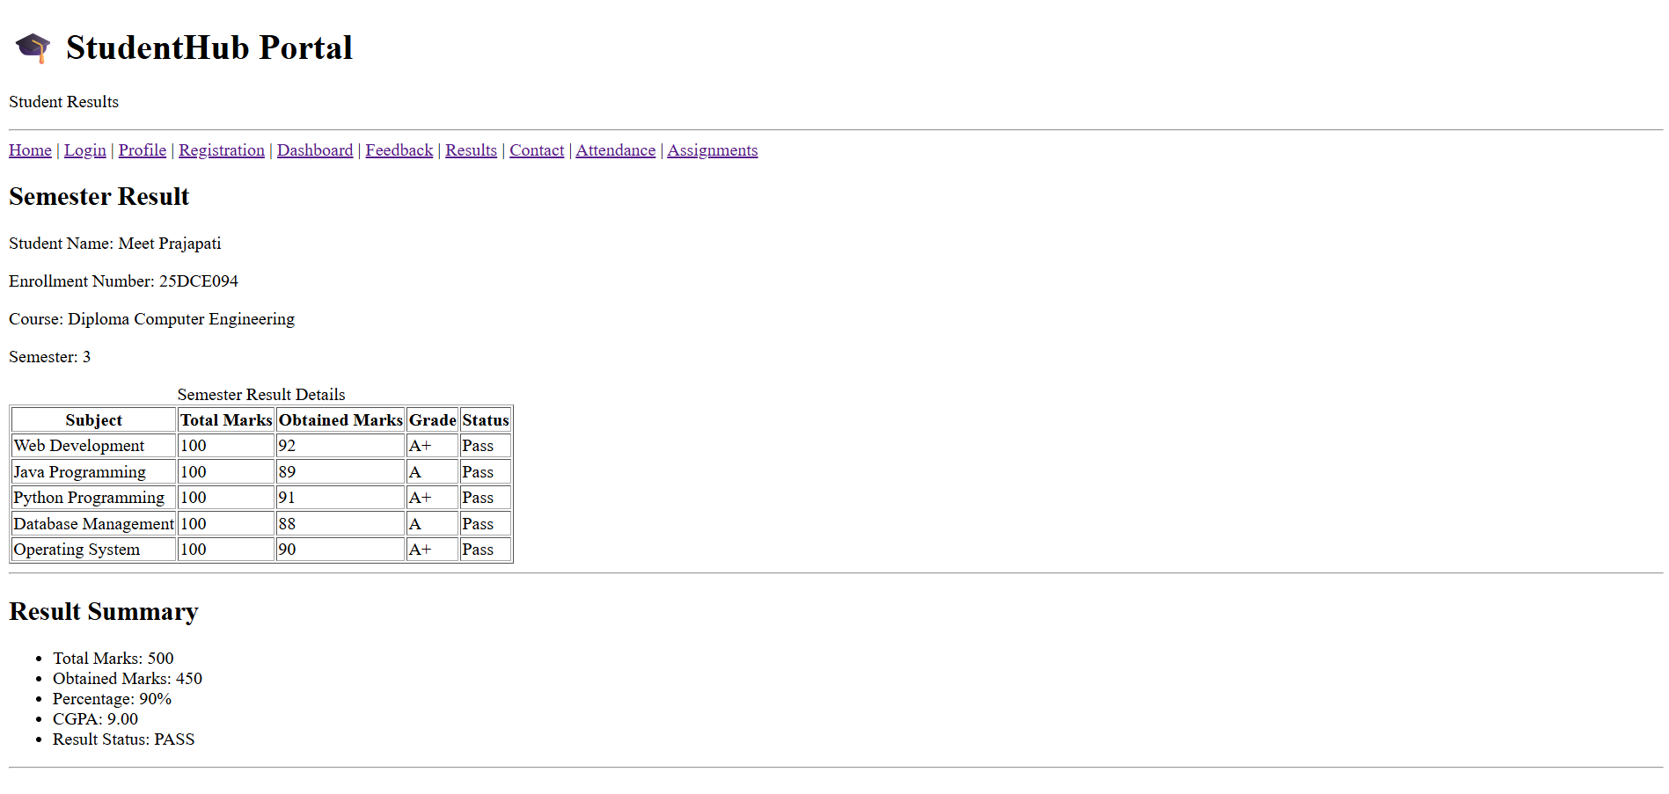

Description: Figure 2.8 shows the Contact Page, created using semantic HTML5 tags to display contact information and provide an accessible way for students to send queries.
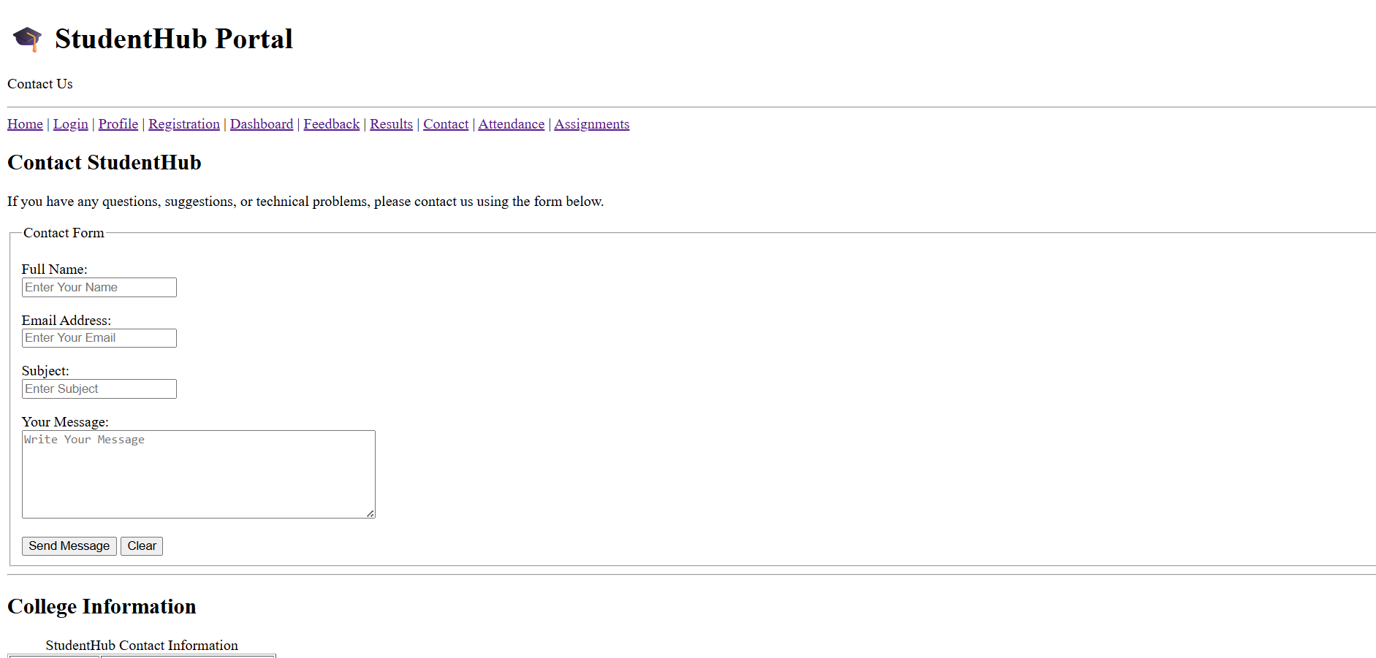

Description: Figure 2.9 shows the Attendance Page, created using semantic HTML5 tags to display subject-wise attendance and attendance percentage clearly.
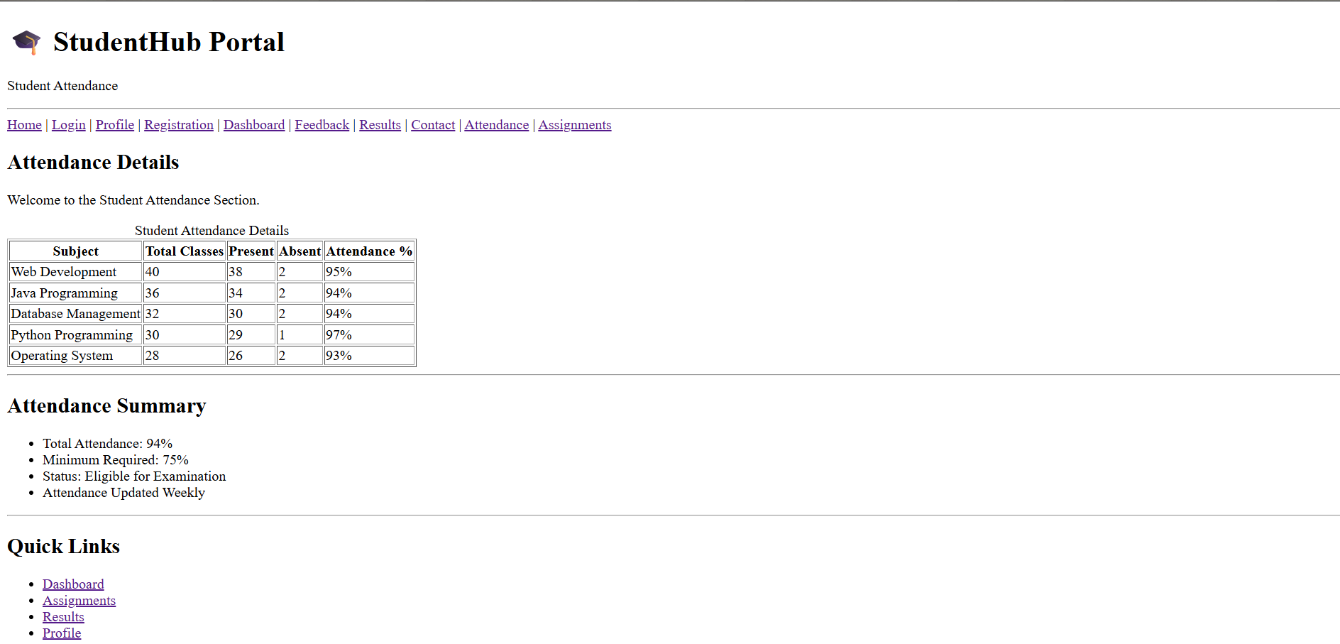

Description: figure 2.10 shows the assignments page, created for using HTML5 tags and to display student assignments and submissions detailed in form of table.
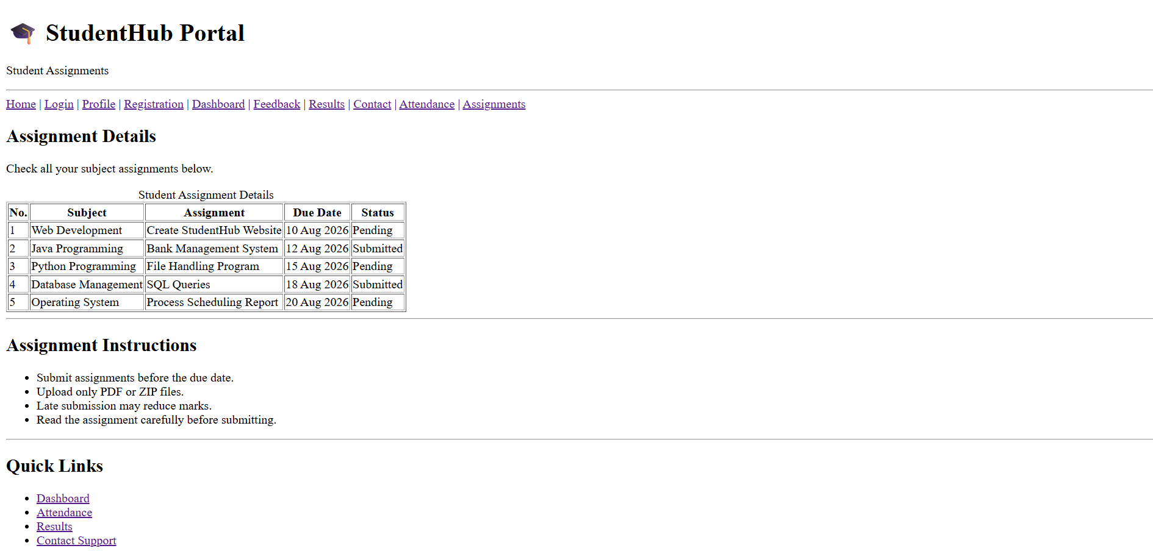

D. GitHub Repository Link:
Link: https://github.com/meetp2m/Student-Portal-Pages-With-Structure-Practical-2

E. Challenges Faced:

Answer: The main challenge was understanding and using HTML5 tags for me. And I learn how add all 10 pages with each other by navigation of h ref.

F. Learning Outcomes:

Answer: I learned how to use HTML5 tags properly and where it is use for what purpose. This practical helped me to understand how to create a simple website page.

G. Faculty Remarks:

